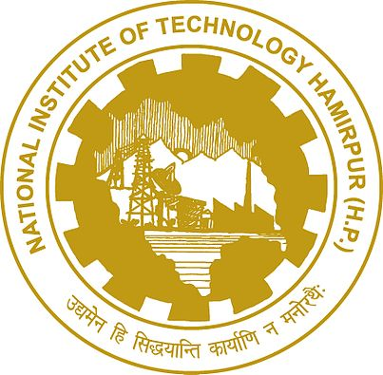

**NIT HAMIRPUR**

National Institute of Technology Hamirpur is one of the thirty NITs of the country, established in 1986 as Regional Engineering College, as a joint and cooperative enterprise of the Govt. of India and Govt. of Himachal Pradesh. The goals of the institute as embodied in the logo are truly remarkable in their scope of vision. The college provide Undergraduate, Postgraduate and Doctorate Education in Engineering, Sciences & Humanities; fostering the spirit of national integration among the students, a close interaction with industry and a strong emphasis on research, both basic and applied.

NIT Hamirpur has 15 departments and 2 centres of excellence. The academic departments at NIT Hamirpur include the following

* Architecture
* Chemical Engineering
* Civil Engineering
* Computer Science and Engineering
* Electrical and Electronics Engineering
* Electronics and Communication Engineering
* Mechanical Engineering
* Industrial Engineering
* Management and Humanities
* Physics
* Chemistry
* Energy and Environment
* Material Science
* Mathematics
* Statistics

The two centres of excellence located at NIT Hamirpur are

* Centre for Excellence in Energy & Environment
* Centre for Material Science and Engineering

